**Design & Implementation of a Dynamic Web-Based Registration System for U.A. University**

**USER MANUAL**

Systems Design And Implementation

Professor Naresh Gupta

| **Hunter Oriol Email: horiol@oldwestbury.edu Phone #: (516)941-8490 Team Leader**  Ganesh Ramcharan Email: gramchar@oldwestbury.edu Phone #: (347)369-1881  Jeriel Salvador Email: jsalvado@oldwestbury.edu Phone #: (631)807-1049 |
| --- |

**Table of Contents**

Content Pg No.

**1. Introduction 4-5**

1.1 Purpose of U.A. University 4

1.2 Target Audience 4

1.3 How to Use This Manual 4-5

**2. Getting Started 6-15**

2.1 Registration 6-12

2.2 Login 13-15

2.3 Being Locked Out and Temporary Password 16-17

**3. Navigation 18-42**

3.1 Visitor Menu18-24

3.2 Student Menu 24-27

3.3 Faculty Menu 27-29

3.4 Admin Menu30-35

3.5 Stats Office Menu36-42

**4. Features and Functionality 44-202**

4.1 Visitor 43-48

4.2 Student 48-74

4.3 Faculty 75-112

4.4 Admin 113-187

4.5 Stats Office 188-202

**5. Troubleshooting 203 - 208**

**6. Contact Information 209**

**7. Glossary 210**

**5. Troubleshooting**

**Login Lockout**

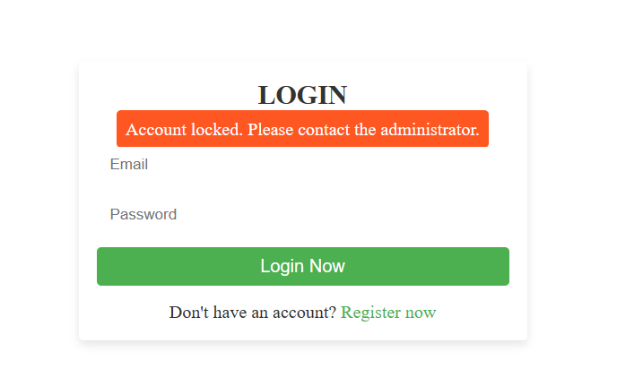

Login lockout occurs when the student, faculty or stats office member enters the wrong password three times. This results in an email being sent to the administrator that holds a temporary password to unlock the account.

**Student Errors**

**Major and Minor Declaring**

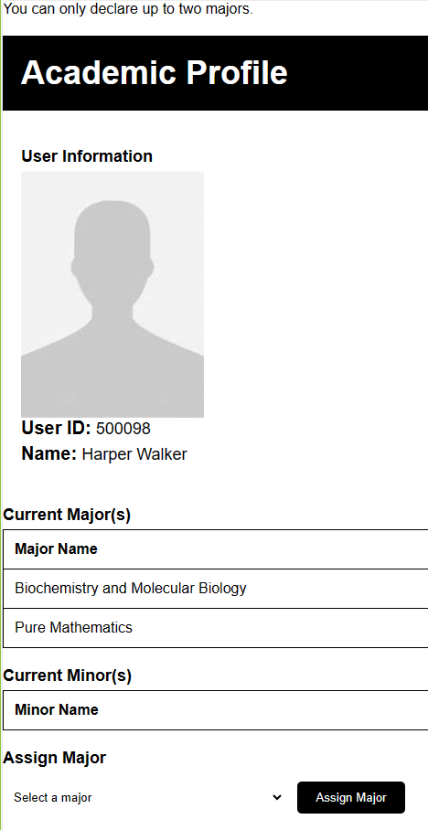

Students can only declare up to two majors. This errors occurs when a student tries to declare another major or minor when they already have one of the two combinations: two majors and one major/one minor.

**Creating Schedule - No Available Seats**

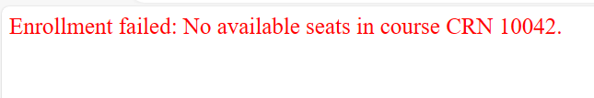

This occurs when a student tries to enroll into a course with no available seats. Should this occur students should look to enroll in the course in a different semester.

**Creating Schedule - Prerequisite Course not fulfilled.**



This occurs when a student attempts to enroll into a course where they have not meet the prerequisite requirements yet. Should this occurs students should seek the listed prerequisite course.

**Creating Schedule - Time Conflict**



This occurs when a student tries to enroll into a course that is at the same time of a course they are currently enrolled in. If students want to take they course they should look for the course in a different semester.

**Creating Schedule - Credits Restriction**

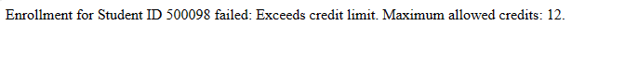

This error occurs when a Full-time student tries to enroll for more than the max 12 credits per semester. This error will also occurs when a Part-time student tries to enroll for more than the max 6 credits per semester. If students want to enroll for another course they should drop a different course

**Admin Errors**

**Faculty Two departments**



This error occurs when an admin tries to assign a faculty to another department while they are already in another department or if they have tried to assign a Part-time member to another department.

**Teaching in Certain Departments**



This error occurs when you try to remove a faculty from a department in which they are already teaching in.

**Chair/Manager Restrictions**



This occurs when an admin tries to assign a Chair or Manager of a certain department to another department. To assign a new chair or manager you must select a faculty member who is not a already one of the two.



This error occurs when an admin tried to select someone out of department to be a chair or manager in a different department.

**Naming Major, Minors, Courses, Course Sections, Departments**

You can’t name Majors, Minors, Courses, Course Sections or Departments the same name as one that already exist.

**Faculty Assigned to Course Outside Department**



This error occurs when you try to assign a faculty to a department out of their current department. You must assign a faculty member to the same department of the selected class.

**Creating Course Section with existing Section Number**



This error occurs when an admin tries to create a Course Section with a CourseID and Section Number that already exists.

**Faculty Class Number**



This error occurs when you try to assign faculty more classes than designed. Full-time can teach up to two classes and Part-time can teach up to one.

**Faculty Time Slot**



This error occurs when an admin tries to assign a faculty to a time in which they are already teaching.

**6. Contact Information**

Hunter Oriol

- Team Leader

- Email: [horiol@oldwestbury.edu](mailto:horiol@oldwestbury.edu)

- Phone Number: (5XX)9XX-8490

Ganesh Ramcharan

- Team Member

- Email: [gramchar@oldwestbury.edu](mailto:gramchar@oldwestbury.edu)

- Phone Number: (3XX)3XX-1881

Jeriel Salvador

- Team Member

- Email: [jsalvado@oldwestbury.edu](mailto:jsalvado@oldwestbury.edu)

- Phone Number: (6XX)8XX-1049

**7. Glossary**

Admin - Administrator

CRN - Course Reference Number

Grad - Graduate

Stats Office - Statistics Office

UID - User Identification Number

Undergrad - Undergraduate